Project 5 – The Last Capture: Game Design Document

# Table of Contents

Table of Contents 1

Title 1

Current Status 1

Inspiration 2

Concept Statement 2

Genre 2

Target Audience 3

Player Experience 3

Concept 3

Art sound and music 3

Current Target Platform (and any system requirements) 4

Core Loops 4

Player objectives and progression 4

Game world 5

User Interface 6

MVP Systems and Features 6

Game Objects 6

Localization 6

Visual research 7

Interior Space design 11

# Title

The Last Capture

# Current Status

This game is currently on its final phase.

# Inspiration

Event: Web summit

Web summit is convention recurring yearly, it is considered to be the world’s largest technological event. It has been happening in Lisbon in the past years.

Being a technological event, it is clear as to how it would connect to our virtual reality, but we even

Thought about adding posters and some little in

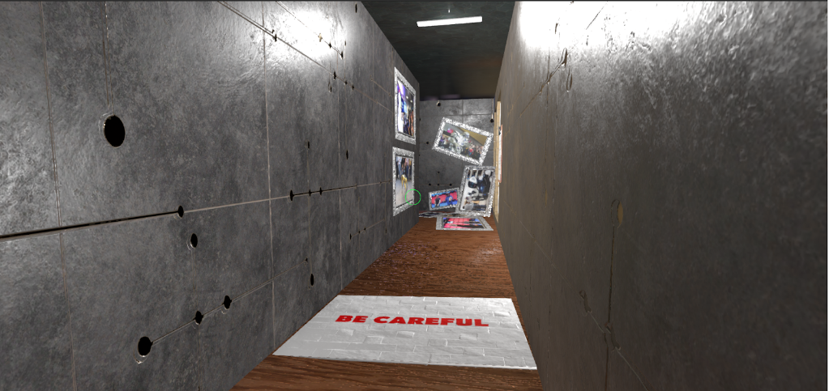Game references to the topic.

These connections would be posters or stickers spread around the game environment.

# Concept Statement

The user plays as a journalist that is late for the web summit convention. He needs to solve puzzles as fast as possible so he can get to the convention. 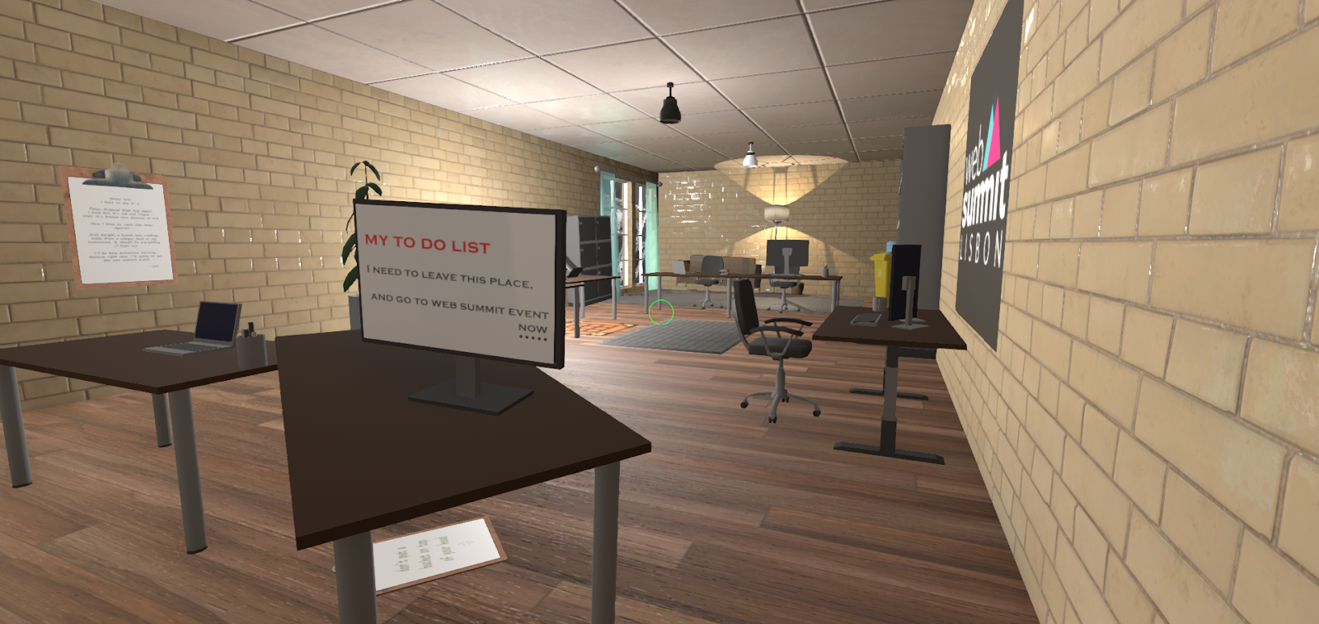

# Genre

Puzzle/Escape Game;

This game will be divided into two parts first, its puzzle aspect, the user will have to complete few puzzles to progress and unlock different areas of the game. And Second the game will have an escape sort of mechanic, where the user will first be chased by a robot, and then by a fire.

# Target Audience

Any Gamer that is in possession of the oculus.

# Player Experience

The players plays as a reporter that fell asleep and woke up late for the web summit convention. Its objective is to get to web summit as fast as possible. The game is thought to last less than an hour.

# Concept

* Inspiration: our event of inspiration is the Web Summit convention. We connected it to our project in different levels:
  + 1. The user plays as a journalist who is late for the convention
  + 2. We Proceeded to add Web Summit posters in the game area
  + 3. The game happens in an office that contains a robot research department, which brings the important technological aspect to our project.
* Objective: the user has for objective to exit the office area, completing series of puzzles and then finally escaping from a mal functioning robot
* Space: as aforementioned, the game area will be divided in two:
  + 1. The office area, using a wooden floor, and office decoration: (desks, tables, chairs, lamps, mugs, computer stuff)
  + 2. The Robot research area, using a tech-like floor, and technological decoration: (server-blocks, reactor cores, research tables)
* Dangers: there will be two dangers to which the player can lose:
  + 1. The robot, when enraged, the robot will chase the player around the game area until the player deactivates its “enraged” mode

2. The fire which will start once the robot turns friendly, and will be progressive, following the player.

# Art sound and music

Visual Style: Low-poly models, with high definition textures, wooden textures for the tables and floors in the office spaces, along with future “tech” textures for the technological areas.

Audio Style:

* Movement: Footsteps sound are played when the player moves
* Environment: door opening sounds added, along with light flickering and object dropping sounds, ambience music added both for the ending and the robot phase shift.
* Damage: when hit the player now screams, this will work as an indicator of him taking damage.
* Robot: the robot now makes a threatening sound when moving alerting the player of its presence

## Current Target Platform (and any system requirements)

Oculus on windows

## Core Loops

o The user will be able to pick up most of the items in the office areas, along those items, some will be required to be picked up in order to solve some of the puzzles. o Once the puzzle areas are solved the player enters the escape aspect of the game, first he must escape the robot while attempting to figure out what happened on the space, and then once he managed to take control of the robot he must escape a fire.

### Player objectives and progression

* The door is closed
* The players looks for elements to produce a door opener
* The door opens
* The player sees the corridor with the lights off o He goes back and grabs the camera for light o He finds the exit room locked
* The player goes in the robot research department
* He falls face to face with the robot (“evil” mode)
* The player escapes the robot
* The player finds the server room and the dead engineer
* He reads the note
* The player moves to desk 1
* He gets the robot control room key
* He goes to the robot control room
* He presses the button to call the robot
* The robot arrives
* The player turns the robot’s “good” mode
* The robot leads the player to the electric room and opens the door
* The power is turned back on
* Has fire has started
* The player escapes
* The fire catches up
* The robot deploys a shield to protect the player
* The player exits.

### Game world

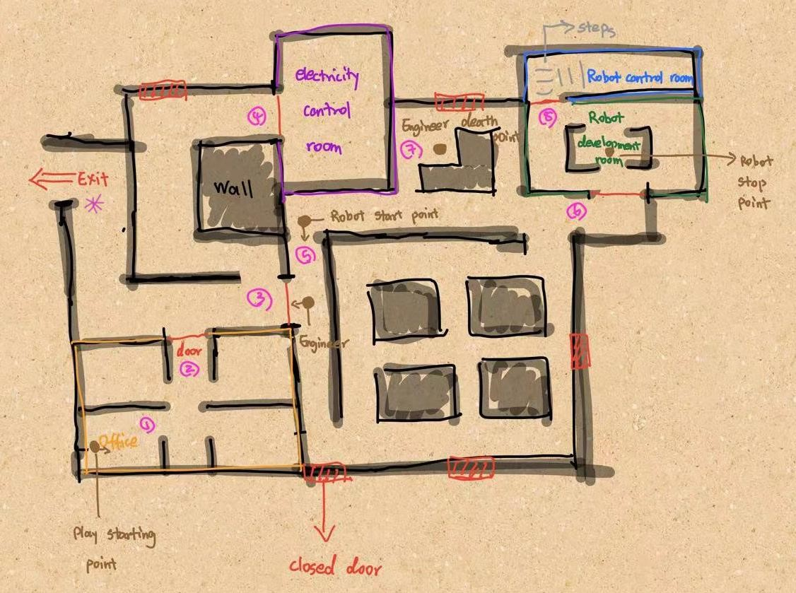

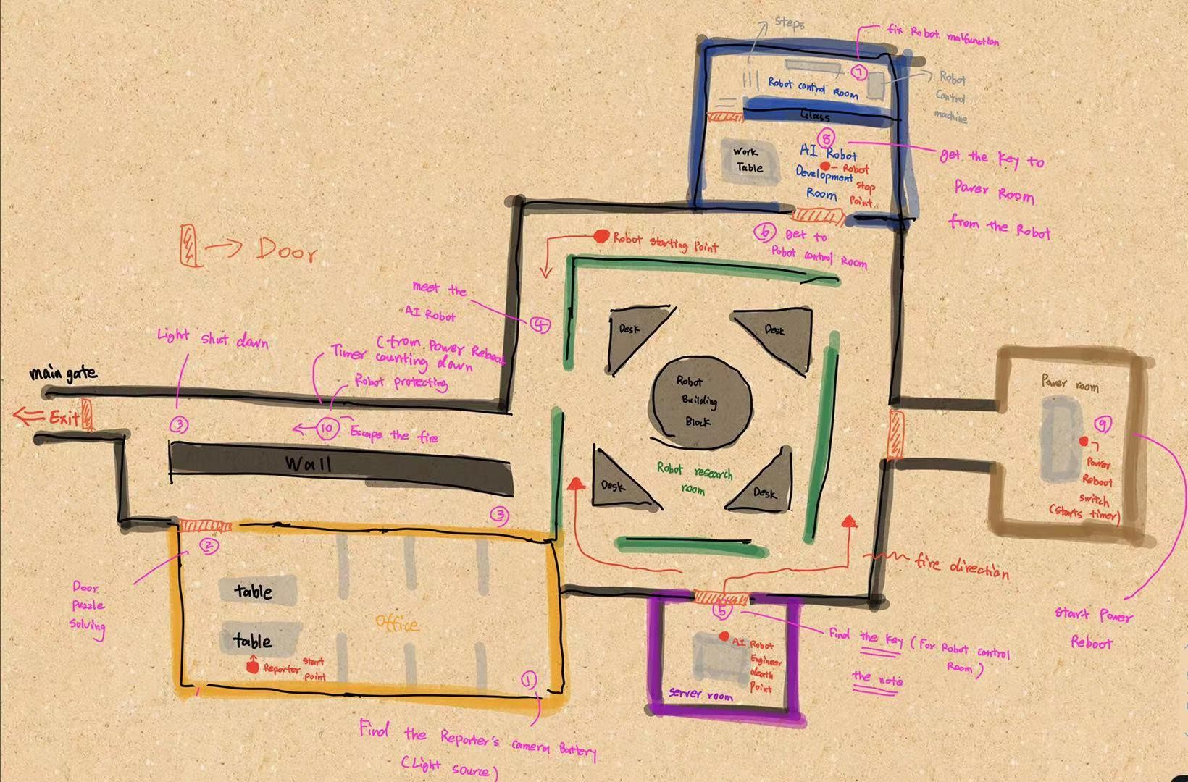

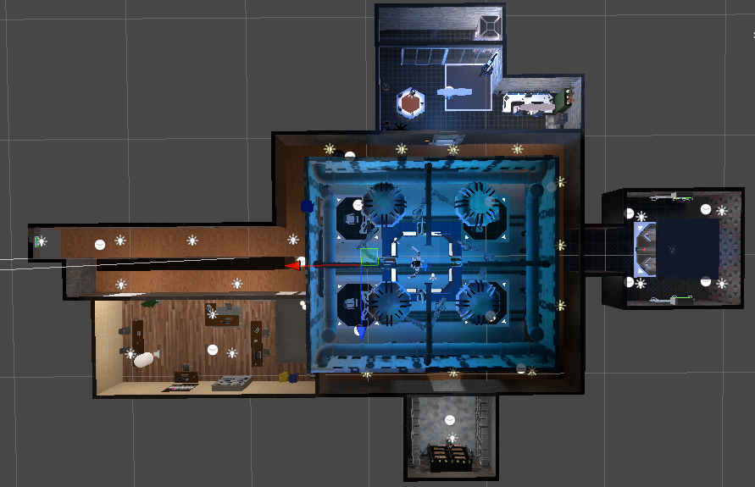

The map is projected to be drawn as an office abandoned, very similar to the environment where occurs Stanley’s Parable, but with colors on the grey pallet, ranging from dark grey to white. The idea would be to recreate a feel similar to Portal and SUPERHOT, but in an office. The puzzle mechanics will be similar to those in Human Fall Flat.

### User Interface

Not much thought was given to the user interface so far but it is thought to follow the original game color pallet: grey scale closer to white.

### MVP Systems and Features

The game is thought to be separated in sections each being identified by the puzzle in need of solving

### Game Objects

Player controller: reporter who fell asleep and got late for the web summit convention.

Robot: The top of technology and Ai in a machine, it got hacked and now haunts the corridors of the robot research facilities.

Engineer: the hero of our story, saved the world from the evil robot AI after it got hacked.

### Localization

Inside an abandoned office, very similar to Stanley’s Parable

# Visual research

Inspirations: Stanley Parable, Portal, Superhot, Human Fall Flat

The idea is to have a clean plain environment. Resembling more a psychiatric hospital rather than a journalism office. The game will be separated in sections, each corresponding to a puzzle needing solving.

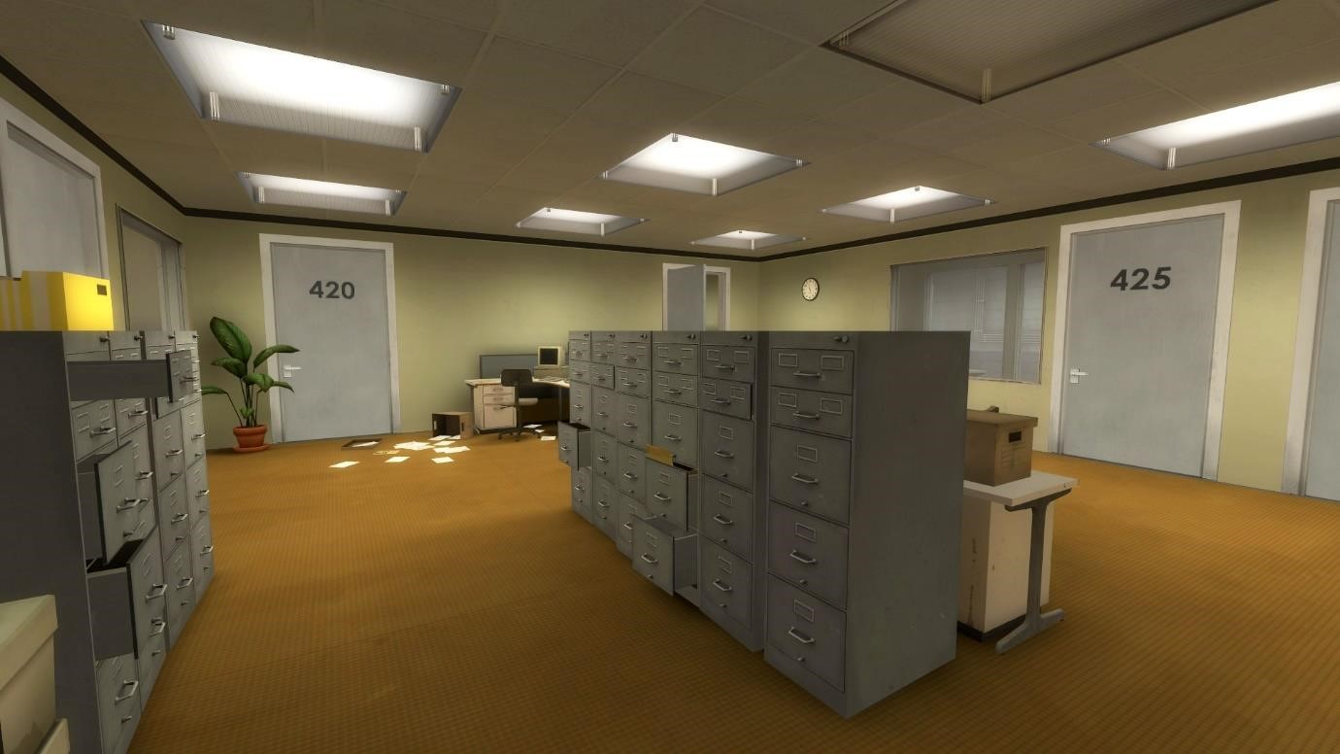

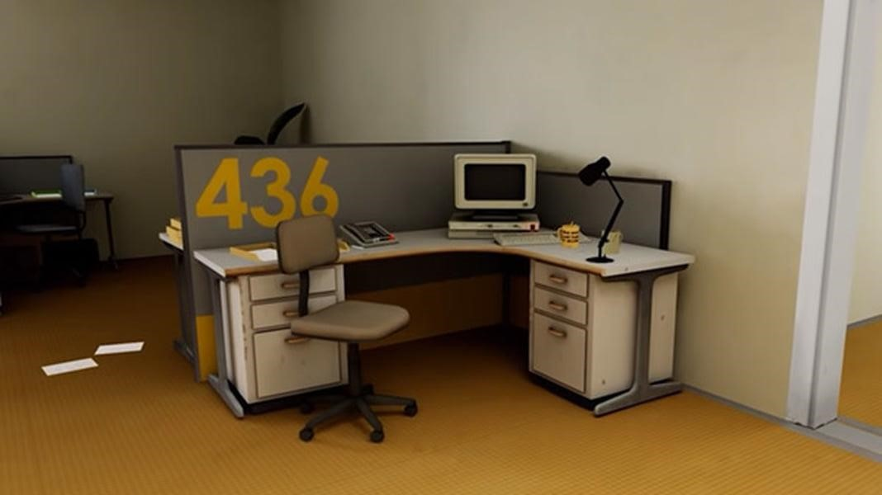

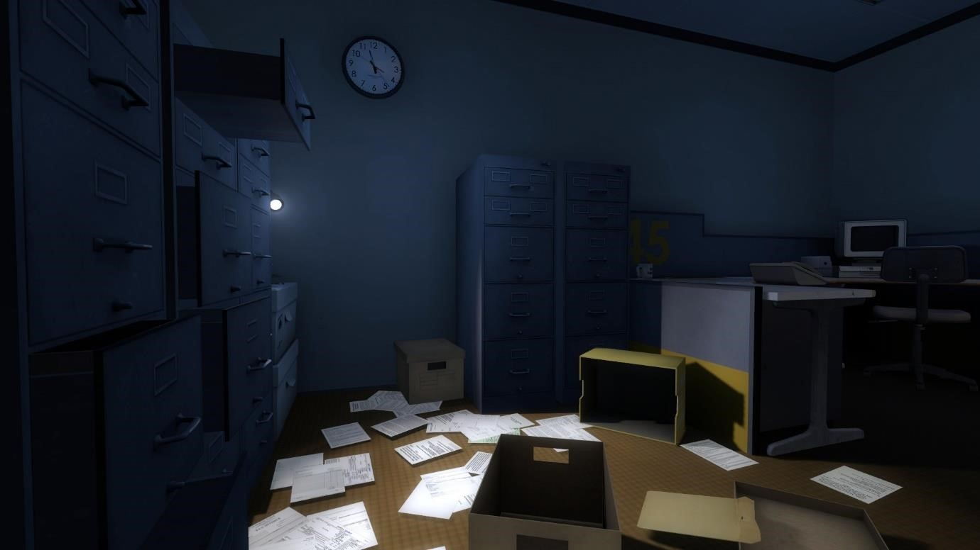

The game would connect with Stanley parable, by having a similar office environment.

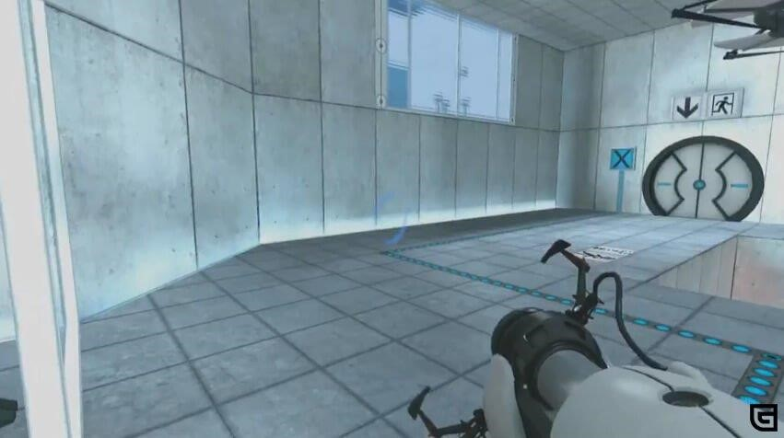

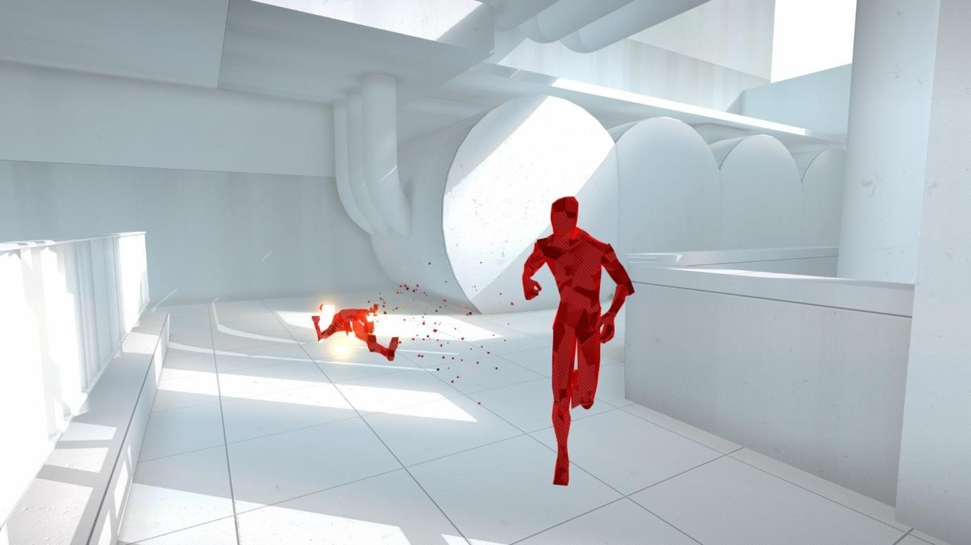

The color pallet will be very similar to the one in SUPERHOT and Portal.

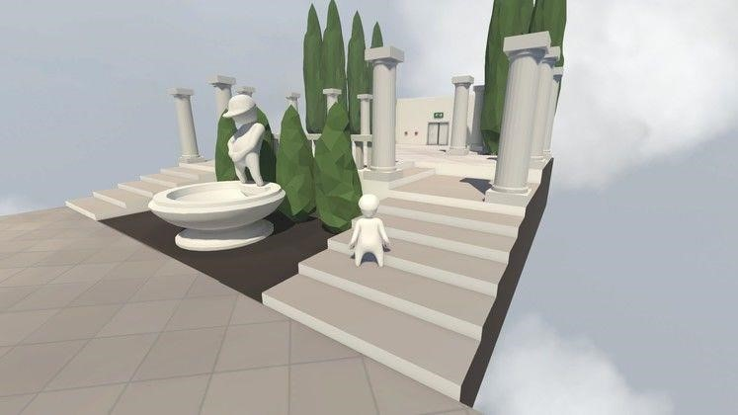

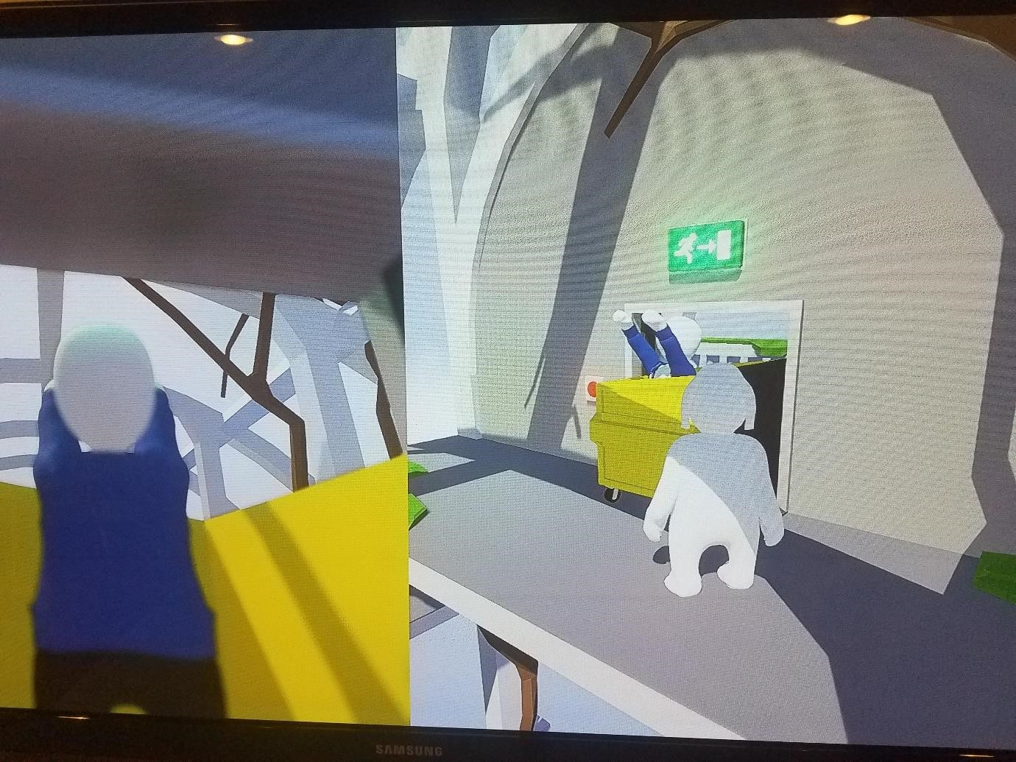

Another game that was used as inspiration was human fall flat, both by his color pallet and by its puzzle mechanics.

Our exit is planned to work on the same way as in human fall flat, having an exit sign that will be lit case the exit is unlocked.

# Interior Space design

# 

